Network Design and Implementation Using VLANs and Wireless Connectivity

1. Introduction
XYZ Company plans to establish a new branch office with three departments: Admin/IT, Finance/HR, and Customer Service/Reception. The objective of this project is to design and implement a network using one Cisco router and one Cisco switch while providing VLAN segmentation, wireless connectivity, automatic IP addressing, and inter-VLAN communication.

2. Objectives
- Design a small enterprise network.
- Create separate VLANs for each department.
- Configure wireless connectivity for users.
- Configure DHCP for automatic IP assignment.
- Enable communication between VLANs using Router-on-a-Stick.

3. Network Requirements
- One Cisco Router
- One Cisco Switch
- Three Departments
  - Admin/IT (VLAN 10)
  - Finance/HR (VLAN 20)
  - Customer Service/Reception (VLAN 30)
- Wireless Access Points
- DHCP Configuration
- Inter-VLAN Communication

4. Network Design

VLAN Addressing Scheme
Department | VLAN | Network Address | Gateway
Admin/IT | 10 | 192.168.1.0/26 | 192.168.1.1
Finance/HR | 20 | 192.168.1.64/26 | 192.168.1.65
Customer Service | 30 | 192.168.1.128/26 | 192.168.1.129

5. Implementation

5.1 VLAN Configuration
VLAN 10 was created for Admin/IT, VLAN 20 for Finance/HR, and VLAN 30 for Customer Service.

5.2 Router-on-a-Stick Configuration
Router subinterfaces were configured to enable communication between VLANs.

5.3 DHCP Configuration
DHCP pools were configured to automatically assign IPv4 addresses to all devices.

5.4 Wireless Configuration
Three wireless access points were configured:
- ADMIN_WIFI
- FINANCE_WIFI
- CUSTOMER_WIFI
Users connected through Wi-Fi and obtained IP addresses automatically.

6. Testing and Verification
The following tests were performed:
- VLAN Verification
- DHCP Verification
- Wireless Connectivity Verification
- Inter-VLAN Communication Verification
Successful ping results confirmed that devices in different VLANs could communicate through the router.

7. Results
The network was successfully implemented according to all requirements. VLAN segmentation improved network organization, DHCP simplified IP management, and wireless connectivity enabled user mobility. Inter-VLAN communication was achieved through Router-on-a-Stick configuration.

8. Conclusion
The project successfully implemented a secure and scalable network infrastructure using VLAN technology, DHCP services, wireless networking, and inter-VLAN routing. All stated requirements were achieved successfully.
Complete Network Topology
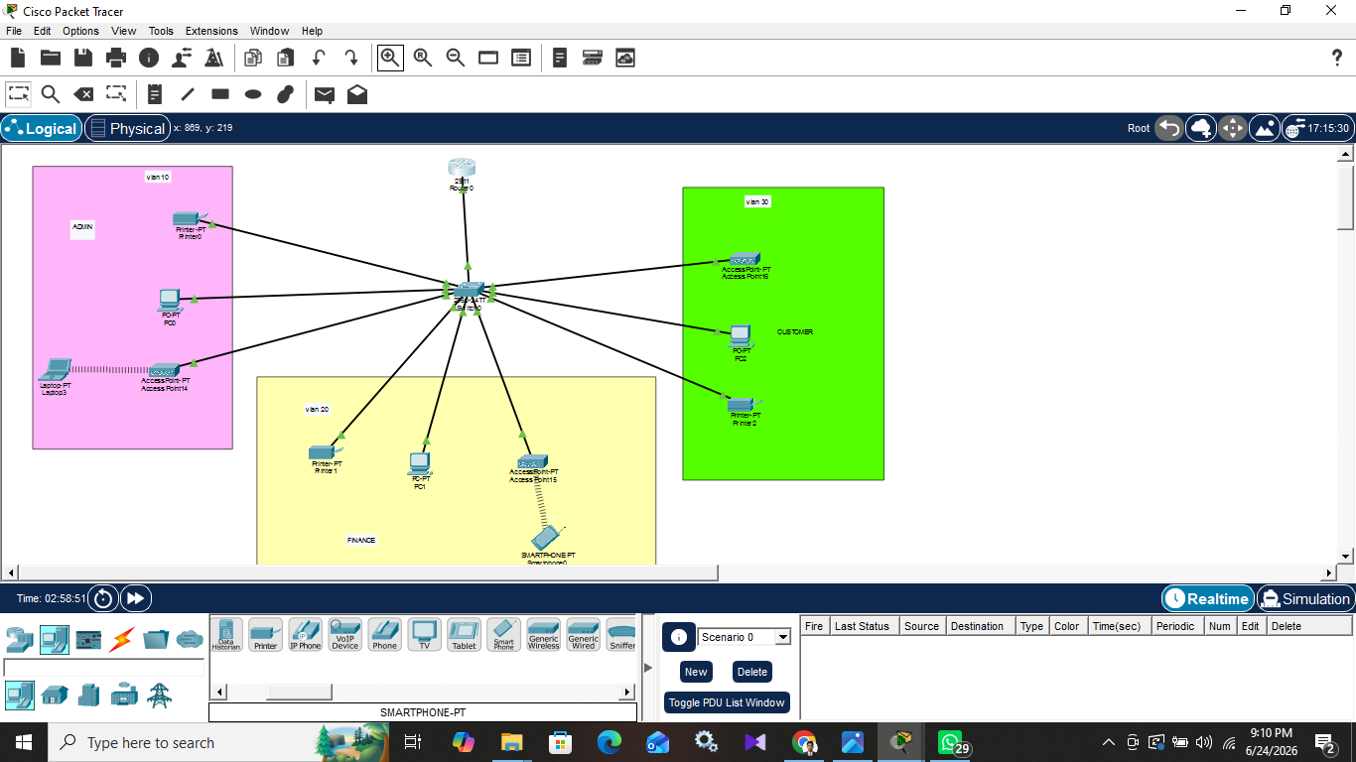

VLAN Configuration, Trunk Configuration 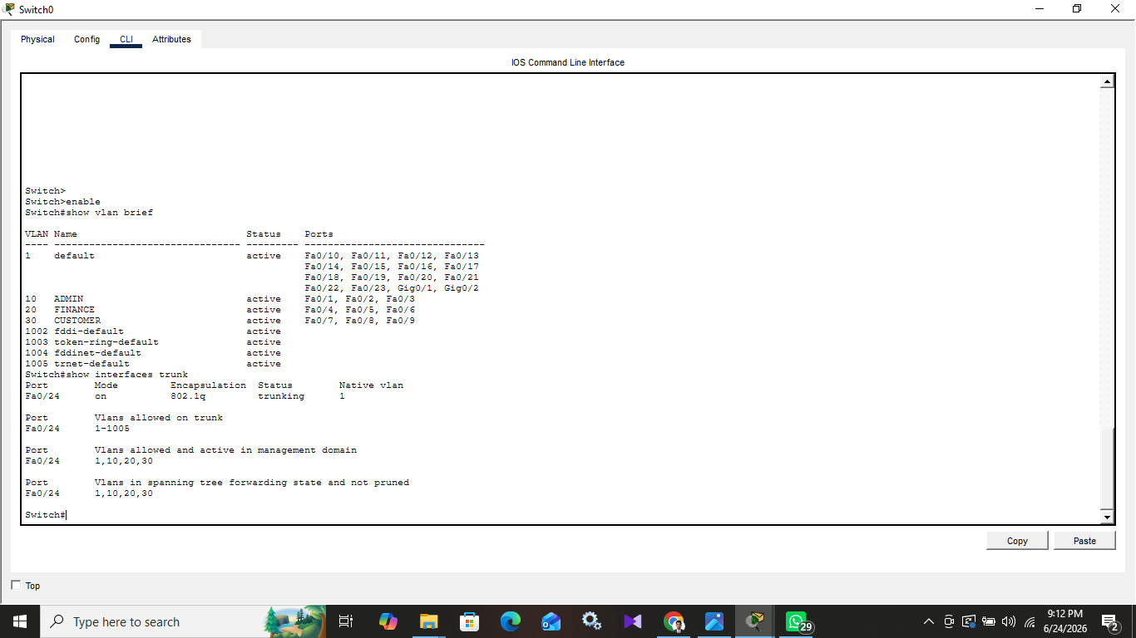

Router Configuration, DHCP Configuration

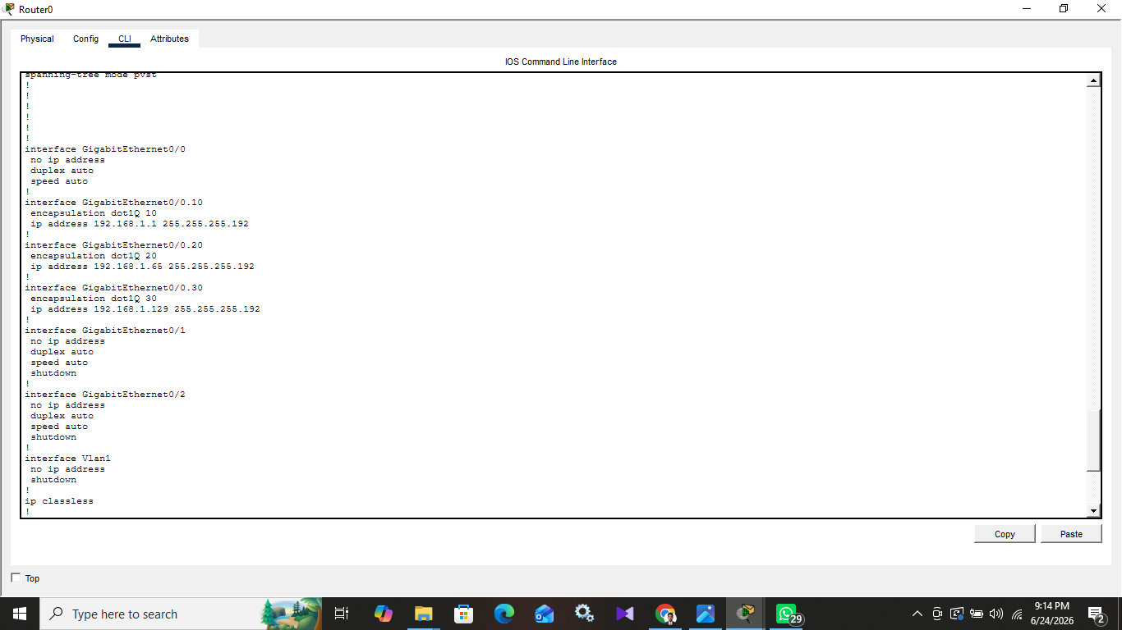

PC, Smartphone Connected to WiFi, Laptop Connected to WiFi

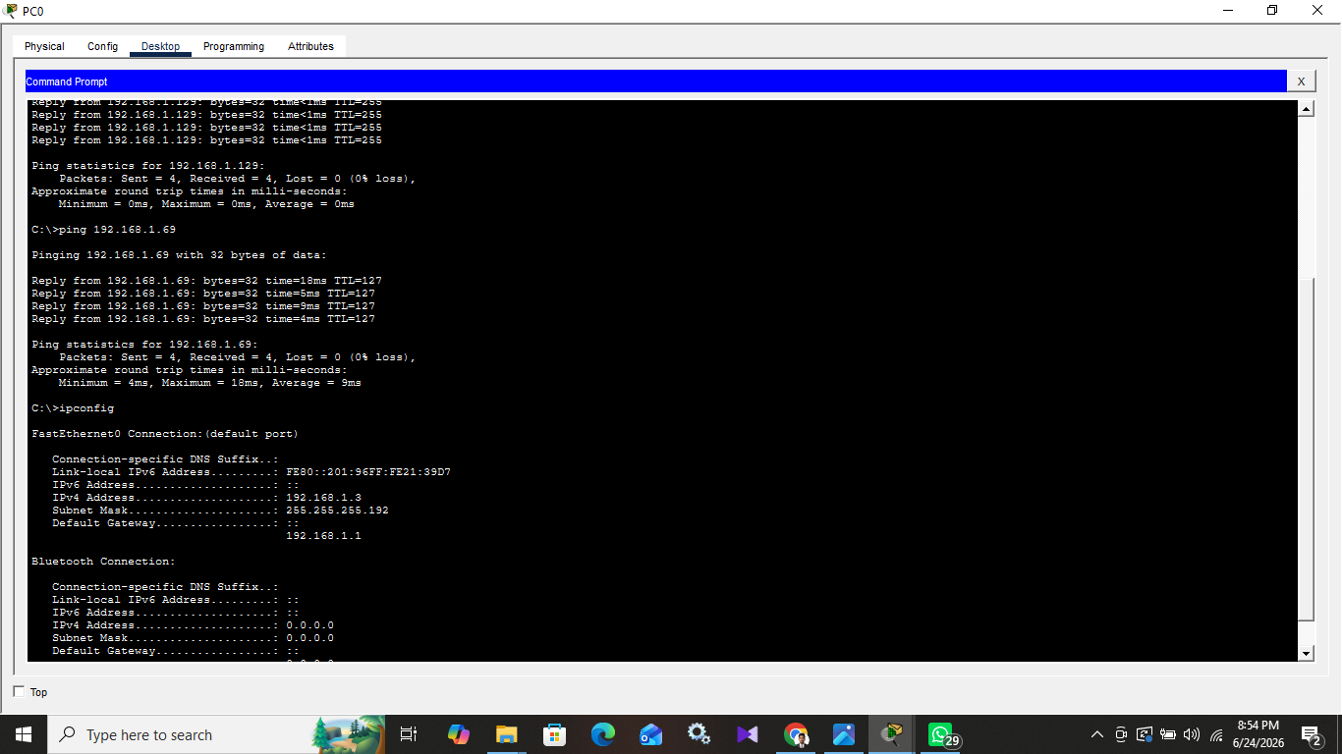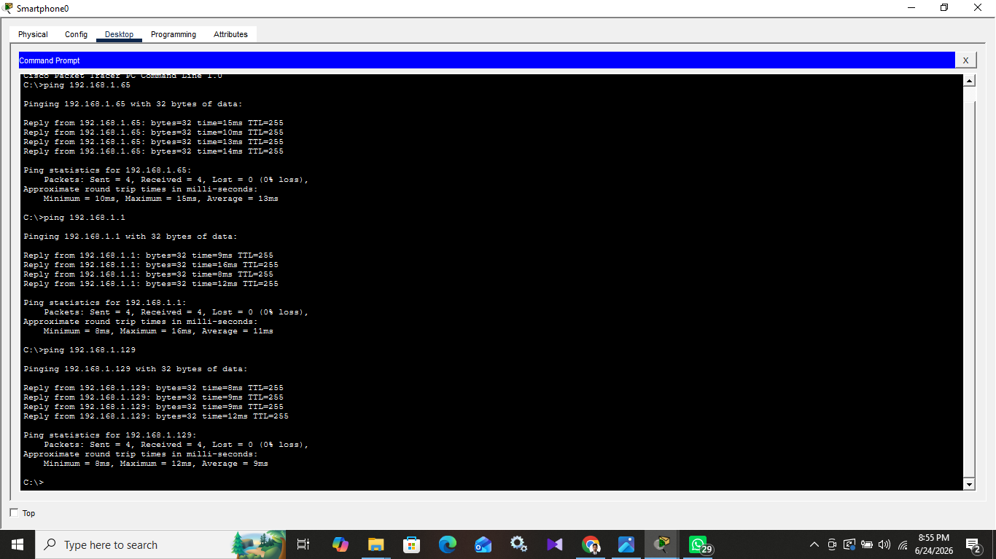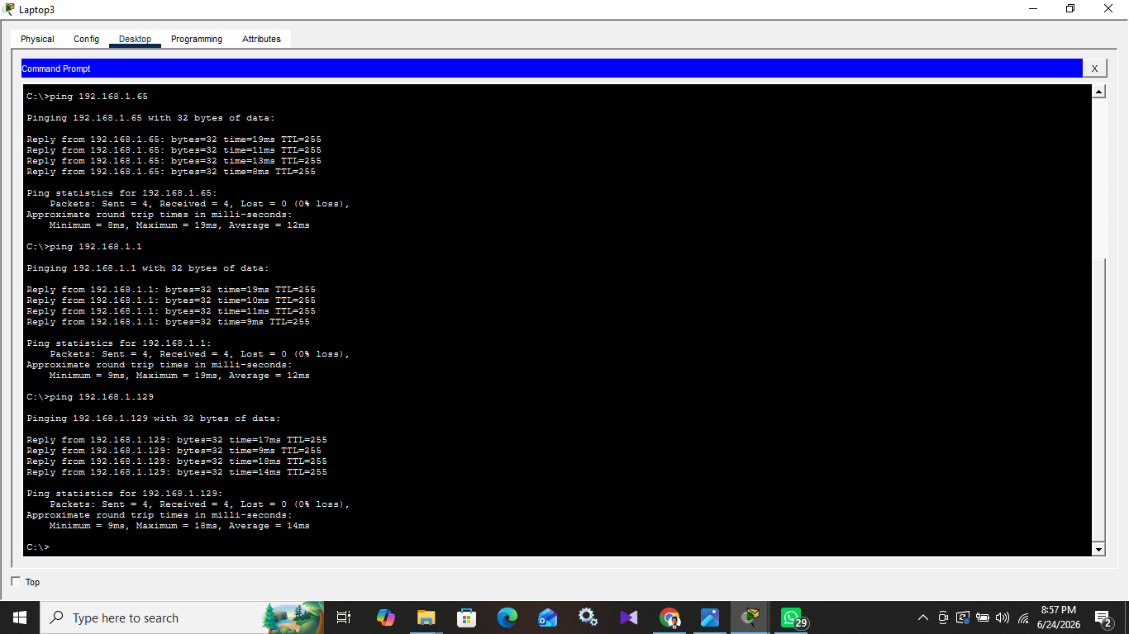

Student Name: Mahesh Thilaksiri
Student ID: 32729
Module: Computer Networks
University: NSBM Green University

